World War I Outcome
Label the following countries. Color in blue all democratic nations on both maps (careful of the time)
Use the area below the map.

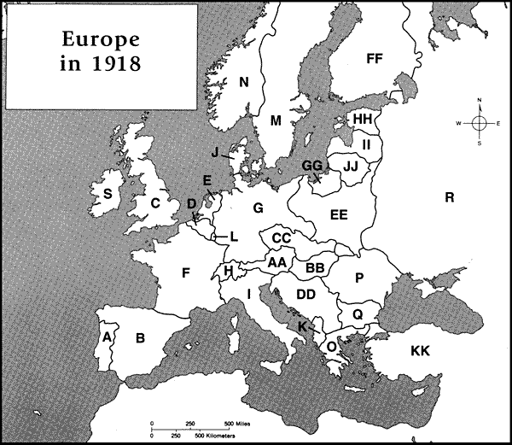

Label the following countries. Use the area below the map.
