AP World History
Supply List:
- Three Ring Binder (2 inch rec)

- Loose leaf notebook paper (college rule)

- Blue or Black Ink Pens

- Number 2 pencils

- A highlighter of any color (suggest multiple colors)

- Purchase the Barron’s book (you can search it by this name; it is available on Amazon as well as many other vendors).

- 7th edition is STRONGLY recommended as the test changes this year
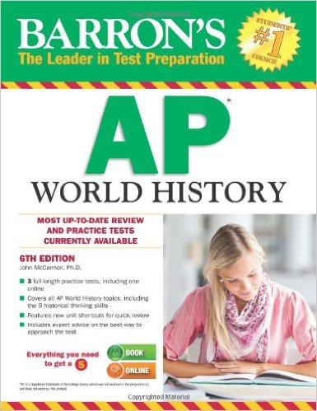 Crash Course is recommended