Julio-Claudian dynasty
Main article: Julio-Claudian dynasty
Portrait | Name |  | Succession |  | Reign |  | Death | Time in Office
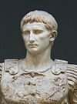 |  | Augustus  IMPERATOR CAESAR DIVI FILIVS AVGVSTVS |  | Great-nephew and adopted son of Julius Caesar; became de facto emperor as a result of the 'first settlement' between himself and the Roman Senate. | January 16, 27 BC  – August 19, 14 AD | August 19, 14 AD  Natural causes or perhaps  poisoning by his wife, Livia ^{[12]} |  |  | 40 Years, 7 Months and 3 days
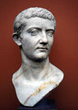 |  | Tiberius  TIBERIVS IVLIVS CAESAR AVGVSTVS |  | Natural son of Livia Drusilla, Augustus' third wife, by a previous marriage, and Augustus' son-in-law; adopted by Augustus as his son and heir. | September 18, 14 AD  – March 16, 37 AD | March 16, 37 AD  Probably natural causes, possibly assassinated  by Caligula |  |  | 22 Years, 5 Months and 27 days
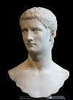 |  | Caligula  GAIVS IVLIVS CAESAR AVGVSTVS GERMANICVS |  | Great-nephew and adoptive grandson of Tiberius, natural son of Germanicus, great-grandson of Augustus. | March 18, 37 AD – January 24, 41 AD | January 24, 41 AD  Assassinated in a conspiracy involving senators  and Praetorian Guards. |  |  | 3 Years, 10 Months and 6 days
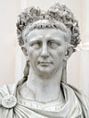 |  | Claudius  TIBERIVS CLAVDIVS CAESAR AVGVSTVS GERMANICVS |  | Nephew of Tiberius, brother of Germanicus, uncle of Caligula, great-nephew-in-law and stepgrandson of Augustus; proclaimed emperor by the Praetorian Guard. | January 25/26, 41 AD – October 13, 54 AD | October 13, 54 AD  Probably poisoned by his wife Agrippina the Younger,  in favour of her son Nero, possibly natural causes. |  |  | 13 Years, 9 Months
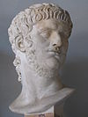 |  | Nero  NERO CLAVDIVS CAESAR AVGVSTVS GERMANICVS |  | Grandson of Germanicus, nephew of Caligula, great-great-nephew of Tiberius, and great-great-grandson of Augustus; great-nephew, stepson, son-in-law, and adopted son of Claudius. | October 13, 54 AD – June 9, 68 AD | June 9, 68 AD  Committed suicide after being declared a public  enemy by the Senate. |  |  | 13 Years, 8 Months

Year of the Four Emperors and Flavian dynasty (Barracks Emperors)
Main articles: Year of the Four Emperors and Flavian dynasty
Portrait | Name | Birth | Succession | Reign | Death | Time in Office
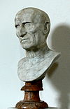 | Galba  SERVIVS SVLPICIVS GALBA CAESAR AVGVSTVS | December 24 3 BC, Near Terracina, Italia | Seized power after Nero's suicide, with support of the Spanish legions | June 8, 68 AD – January 15, 69 AD | January 15, 69 AD  Murdered by Praetorian Guard in coup led  by Otho. | 7 months and 7 days
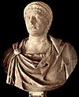 | Otho  MARCVS SALVIVS OTHO CAESAR AVGVSTVS | April 28, 32 AD, Ferentinum, Etruria, Italia | Appointed by Praetorian Guard | January 15, 69 AD – April 16, 69 AD | April 16, 69 AD  Committed suicide after losing  Battle of Bedriacum to Vitellius | 3 months 1 day (91 days)
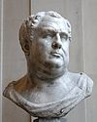 | Vitellius  AVLVS VITELLIVS GERMANICVS AVGVSTVS | September 24, 15 AD, Rome | Seized power with support of German Legions (in opposition to Galba/Otho) | April 17, 69 AD – December 20, 69 AD | December 20, 69 AD  Murdered by Vespasian's troops | 8 Months
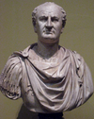 | Vespasian  TITVS FLAVIVS CAESAR VESPASIANVS AVGVSTVS | November 17, 9 AD, Falacrine, Italia | Seized power with the support of the eastern Legions (in opposition to Vitellius) | December 21, 69 AD – June 24, 79 AD | June 24, 79 AD  Natural causes | 10 years
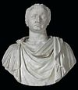 | Titus  TITVS FLAVIVS CAESAR VESPASIANVS AVGVSTVS | December 30, 39 AD, Rome | Son of Vespasian | June 24, 79 AD – September 13, 81 AD | September 13, 81 AD  Natural causes (fever) | 2 years, 3 months
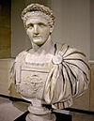 | Domitian  TITVS FLAVIVS CAESAR DOMITIANVS AVGVSTVS | October 24, 51 AD, Rome | Son of Vespasian | September 14, 81 AD – September 18, 96 AD | September 18, 96 AD  Assassinated by court officials | 15 years

Nerva–Antonine dynasty (Good Emperors)
Main article: Nerva–Antonine dynasty
Portrait | Name | Birth | Succession | Reign Death |  |  | Death | Time in Office
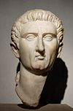 | Nerva  MARCVS COCCEIVS NERVA CAESAR AVGVSTVS | November 8, 30 AD, Narni, Italia | Appointed by the Senate | September 18, 96 AD – January 27, 98 AD |  | January 27, 98 AD  Natural causes |  | 1 year, 4 months
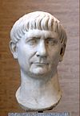 | Trajan  CAESAR MARCVS VLPIVS NERVA TRAIANVS AVGVSTVS | September 18, 53 AD, Italica, Hispania Baetica | Adopted son and heir of Nerva | January 28, 98 AD – August 7, 117 AD | August 7, 117 AD  Natural causes |  |  | 19 years, 7 months
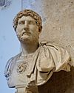 | Hadrian  CAESAR PVBLIVS AELIVS TRAIANVS HADRIANVS AVGVSTVS | January 24, 76 AD, Italica, Hispania Baetica (or Rome) | Adopted son and heir of Trajan | August 11, 117 AD – July 10, 138 AD | July 10, 138 AD  Natural causes |  |  | 21 years
 | Antoninus Pius  CAESAR TITVS AELIVS HADRIANVS ANTONINVS AVGVSTVS PIVS | September 19, 86 AD, Near Lanuvium, Italia | Adopted son and heir of Hadrian | July 10, 138 AD – March 7, 161 AD | March 7, 161 AD  Natural causes |  |  | 22 years, 7 months
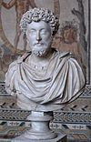 | Marcus Aurelius  CAESAR MARCVS AVRELIVS ANTONINVS AVGVSTVS | April 26, 121 AD, Rome | Adopted son, son-in-law and heir of Antoninus Pius; Co-emperor with Lucius Verus until 169 AD | March 7, 161 AD – March 17, 180 AD | March 17, 180 AD  Natural causes |  |  | 19 years
 | Lucius Verus  CAESAR LVCIVS AVRELIVS VERVS AVGVSTVS | December 15, 130 AD, Rome | Adopted son and heir of Antoninus Pius and son-in-law of Marcus Aurelius; Co-emperor with Marcus Aurelius until death | March 7, 161 AD – ? March 169 AD | March 169 AD  Natural causes (Plague) |  |  | 8 years
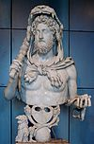 | Commodus  CAESAR MARCVS AVRELIVS COMMODVS ANTONINVS AVGVSTVS | August 31, 161 AD, Lanuvium, Italia | Natural son of Marcus Aurelius; joint emperor from 177 AD | 177 AD – December 31, 192 AD | December 31, 192 AD  Assassinated in palace, strangled to death |  |  | 15 years

The Dominate

Tetrarchy and Constantinian dynasty
Portrait | Name | Birth | Succession | Reign | Death | Time in Office
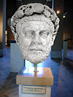 | Diocletian  CAESAR GAIVS AVRELIVS VALERIVS DIOCLETIANVS AVGVSTVS | c. December 22, 244 AD, Salona | Proclaimed emperor by army after death of Numerian, and in opposition to Carinus; adopted Maximian as senior co-emperor in 286 AD | November 20, 284 AD – May 1, 305 AD | 3 December 311 AD  Abdicated; died of natural causes in  Aspalatos | 20 years
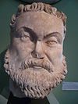 | Maximian  CAESAR GAIVS AVRELIVS VALERIVS MAXIMIANVS AVGVSTVS | c. 250 AD, near Sirmium, Pannonia | Adopted as senior co-emperor ('Augustus') in the west by Diocletian in 286 AD | April 1, 286 AD – May 1, 305 AD | 310 AD  Abdicated with Diocletian; twice tried to  regain throne with, and then from  Maxentius; captured by Constantine I  and committed suicide at his behest | 19 years
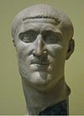 | Constantius I Chlorus  CAESAR GAIVS FLAVIVS VALERIVS CONSTANTIVS AVGVSTVS | March 31 c. 250 AD, Dardania, Moesia | Adopted as junior co-emperor ('Caesar') and heir by Maximian in 293 AD | May 1, 305 AD – July 25, 306 AD | 306 AD  Natural causes | 1 year and 2 months
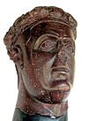 | Galerius  CAESAR GALERIVS VALERIVS MAXIMIANVS AVGVSTVS | c. 260 AD, Felix Romuliana, Moesia Superior | Adopted as junior co-emperor ('Caesar') and heir by Diocletian in 293 AD. Also son-in-law of Diocletian. | May 1, 305 AD – May 311 AD | 311 AD  Natural causes | 6 years
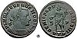 | Severus II  FLAVIVS VALERIVS SEVERVS AVGVSTVS | ? | Adopted as junior co-emperor ('Caesar') and heir by Constantius I Chlorus in 305 AD; succeeded as Augustus in 306; opposed by Maxentius and Constantine I | Summer 306 AD – March/ April 307 AD | September 16, 307 AD  Captured by Maxentius and forced to  commit suicide (or murdered) | 1 year
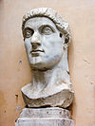 | Constantine I  CAESAR FLAVIVS CONSTANTINVS VALERIVS AVGVSTVS | February 27 c. 272 AD, Naissus, Moesia Superior | Son of Constantius I Chlorus, proclaimed emperor by his father's troops; accepted as Caesar (west) by Galerius in 306 AD; promoted to Augustus (west) in 307 AD by Maximian after death of Severus II; refused relegation to Caesar in 309 AD | 25 July 306 AD – May 22, 337 AD | May 22, 337 AD  Natural causes | 31 years

