Sui, Tang, and Song Dynasties
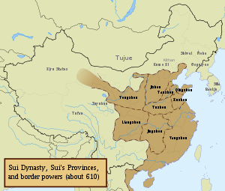
Sui, Tang, and Song Dynasties
Sui
Yang Jian established this short-lived dynasty in 581 after making a boy-emperor abdicate his throne. He created a very centralized state and commissioned many public projects. One ambitious project was the Grand Canal, a canal leading from Hangzhou to Chang'an and Beijing. It was finished during Sui Yangdi's reign, 604 to 618 C.E., and was built to facilitate the transport of southern farm foods to northern provinces. All of these public works required high levies and numerous conscripted laborers, which angered many people. In 618, an angry minister assassinated Sui Yangdi, ended the Sui Dynasty, and began

.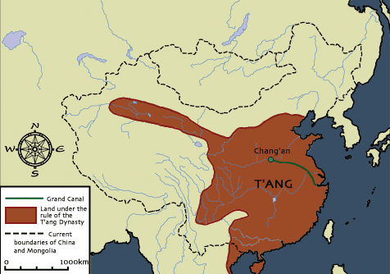
The Tang Dynasty: Tang After the fall of the Sui Dynasty in 618, a rebel leader took Chang'an and established the Tang Dynasty. The Tang Dynasty's second emperor, Tang Taizong (who reigned from 627 to 649 C.E.), was the main catalyst for the dynasty's success. He lowered taxes, fought crime to the point of its end, and worked to establish a faithful, stable government. The Tang Emperors also expanded their empire to cover Manchuria, Mongolia, Tibet, andKorea. The Tang people also wrote extensive poetry about their daily lives. Much of it has survived and has helped scientists understand what the common people went through in this time. The Tang's bureaucracy was based on the civil service exam, a strenuous test that told if a person was good enough for government service. The examinees would study for years beforehand and some would take the test multiple times in order to succeed. As the positions in the bureaucracy were acheived by merit, those bureaucrats kept their jobs as China changed rulers. Their order was based on meritocracy, positions that are earned, rather than aristocracy, positions that are inherited. They also introduced more advanced forms oftransportation and communication. With the establishment of numerous canals, communication and trade got a lot easier and faster. The Tang government introduced better forms of paper money and letters of credit too. Tributes were collected from the neighboring states that they conquered at Chang'an during the Tang Dynasty. Chang'an became a large trade city, as such, and incorporated many religions and cultures in itscosmopolitan nature. Woman's rights didn't get a lot of attention during the Tang Dynasty, but there was a few advances under the leadership of the only empress of China, Wu Zhao. She supported the poor and was brutal to her adversaries. Buddhism, Islam, Nestorianism, Mincheanism, andZoroastrianism all gained a foothold in China during this period. Daoism and Confucianism were already prevalent here, and they even felt threatened by a few of the new incoming religions. The Chinese bureaucracy destroyed and bankrupted Buddhist temples because they believed the Buddhists were expensive and an enemy to the government. The monks were anti-materialistic and believed the central government didn't need to have a big treasury as it did. The Daoists and Confucians retaliated by oppressing the monks and taking away their land. Towards the end of the dynasty, Neo-Confucianism started to rear its head as a blending of Buddhist and Confucian beliefs. It collapsed in 907 C.E. due to it spreading too thin to protect itself from the interests of the local warlords.
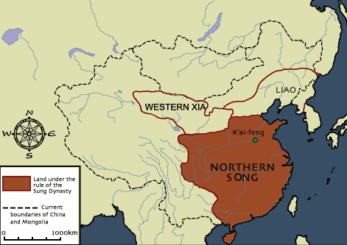
- Song:The Song Dynasty was established after a period of warfare lasting 53 years by its first emperor, Emperor Taizu. He continued the tradition of a highly centralized central government that gave some power and authority to local governments. The arts were greatly developed during the Song Dynasty. The invention of the printing press helped the spread of new literary works, like encyclopedias and history books. The combination of a strong central government and the spread of Confucian ideals led to a very stable government that lasted for more than 300 years. The leaders of the Song also continued the practice of the tributary system, when local tribes paid tribute to the Song Dynasty in recognition of his power. The Song Dynasty was smaller than the Tang Dynasty, because nomads from the north forced them to relocate the capitol to Hangzhou. The new invention ofgunpowder prevented further shrinking of the empire, however. A new type of ship, the junk, helped Chinese merchants get to farther areas with more cargo. New advances in iron production and rice production from Vietnam led to a big increase in population in China. The practice of foot binding, the binding of a young girl's feet to keep them small and unuseable, became very prevalent during the Song Dynasty. This was to keep women dependent on men and to make them subservent to men. The Neo-Confucian ideals, popularized at the end of the Tang Dynasty, became the political doctrine for the Song Dynasty. This also led to influence in Japanese political thought due to trade between the regions.

